# Describe how session can be used if cookies are disabled in browser?

If cookies are disabled in the browser, sessions can be maintained using a technique called "session ID in the URL." This involves appending a unique session ID to the URL, which the server uses to identify the user and maintain their session. The session ID is typically stored on the server, and the server looks up the session information based on the session ID included in the URL. This method can be less secure than using cookies because the session ID is visible in the URL and can be intercepted by malicious actors. Additionally, it can be a problem for users who share the links with others.

# What is Access Control List (ACL)? Describe how would you manage the authentication and authorization in your web applications?

An Access Control List (ACL) is a list of permissions that dictate who or what is allowed to access a resource, such as a file or network resource. An ACL can include entries that grant or deny access to specific users or groups, as well as default entries that apply to all users.

To manage authentication and authorization in web applications, there are several common approaches:

* Using a username and password: Users provide their credentials to the application, which verifies them against a stored list of valid users or an external authentication service.
* Using token-based authentication: Users are issued a token upon successful authentication, which they present to the application with each subsequent request. The application verifies the token and grants access based on the permissions associated with the token.
* Using an external service: Applications can rely on external services, such as social media or enterprise-level authentication services to authenticate users.
* Using role-based access control (RBAC): In this method, users are assigned to roles, which are granted certain permissions. When a user attempts to access a resource, the application checks their role and grants or denies access based on the permissions associated with that role.

Once the user is authenticated, the application can use the ACL to check the user's permissions and decide whether to grant or deny access to the requested resource.

# Describe with the help of (Entity Relationship) ER diagram the database design which you would create to handle the ACL of your web application.

An ER diagram is a visual representation of the entities and their relationships in a database. Here is an example of how the database design for an ACL system might look:

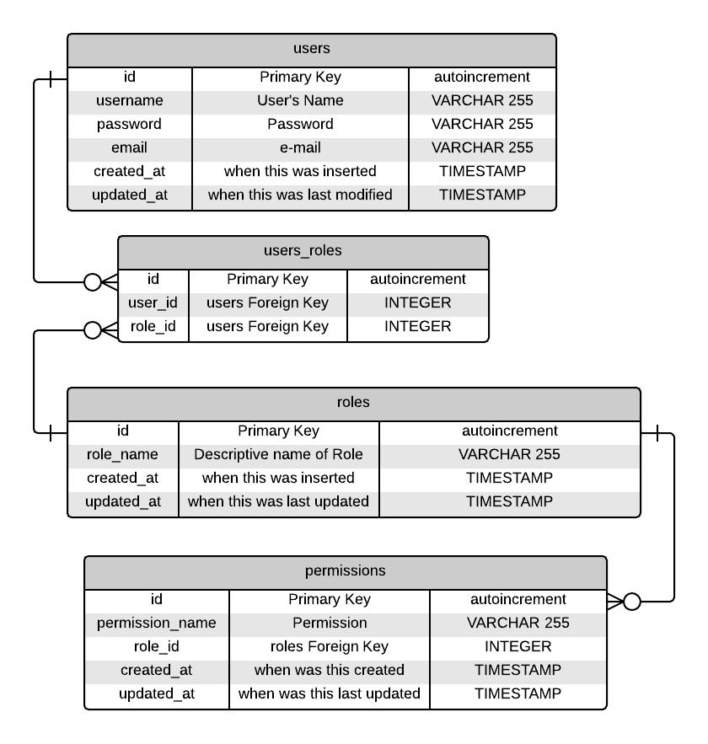

In this example, there are four main entities:

* Users: This represents the users of the web application. Each user has a unique ID and associated information such as username and password.
* Roles: This represents the different roles in the application, such as "admin" or "user." Each role has a unique ID and a name.
* Resources: This represents the resources that the application controls access to, such as pages or files. Each resource has a unique ID and a name.
* Permissions: This represents the permissions that are granted or denied to specific roles for specific resources. Each permission has a unique ID and includes a reference to the role and resource it applies to, as well as a flag indicating whether it grants or denies access.

The relationships between the entities are as follows:

* A user can have multiple roles (a user is assigned to one or more roles)
* A role can have multiple permissions (a role is associated with one or more permissions)
* A resource can have multiple permissions (a resource is associated with one or more permissions)

This is a simple example of how an ER diagram for an ACL system might look, it can be adjusted or changed according to the complexity of the application.

# PHP is a scripting language. When compared to the compiled program, scripts run slower. Write atleast two steps that you would take to increase the performance of your web application.

There are several steps that can be taken to increase the performance of a PHP web application. Here are two examples:

* Use caching: Caching can significantly improve the performance of a web application by storing the result of expensive operations, such as database queries, in memory. This allows the application to retrieve the results quickly without having to perform the operation again. There are several caching solutions available for PHP, such as APC (Alternative PHP Cache) or Memcached.
* Optimize database queries: One of the most common performance bottlenecks in web applications is the database. By optimizing your database queries, you can reduce the number of queries required to retrieve data, and ensure that the queries that are run are as efficient as possible. This can be done by using indexes, writing efficient SQL statements, and limiting the amount of data retrieved by each query.
* PHP accelerator: like Zend Optimizer or ionCube to increase the performance of your PHP script by caching compiled bytecode and providing additional performance enhancements.
* Content Delivery Network (CDN): to distribute the static resources of your web application, which will increase the performance of your application for the users who are far away from the server.

# What is the concept of counter cache? Explain with help of an example.

# Custom routes are necessary components of any web application. Frameworks like Laravel offer a separate component to handle routing, resulting in performance issues due to analysis of incoming routes. How can you improve the performance issues raised by dynamic routing component?

# What is Cross-Site Request Forgery (CSRF)?

# How Laravel framework handles CSRF attacks by default?

# What are default form submission methods which HTML support and what is the main difference between them?

# What extra form submission methods the Laravel framework provides?

# What is Content Delivery Network (CDN)?

# Current version of bootstrap file size is around 130kb which is overburden as you would not be using all of the bootstrap features. How will you satisfy your client that bootstrap would not waste his/her bandwidth.